Renju lesson on December 28, 2000

Hello all! Welcome to Online Renju Class. Today we will continue learning d8 opening. Those who want to download the lesson file, they can do it right after the lesson is over by downloading it from renjuclass.com. The file will be available on website 5 minutes after the end of lesson.
We will learn another 8th move – the strongest 8th move – i7.
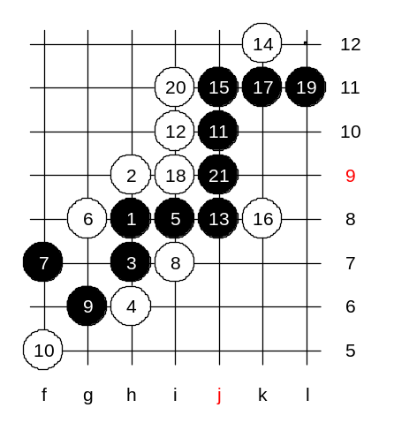
Although it gives black sure win, so many people still play it. I checked the database records of renju tournaments – this 8th move was used in 251 games. The reason why people play it is that the black win is so difficult and most people do not have enough knowledge and still to win in such situations.
Move 11-j10 – the beginning of development. There are several 12th moves to be tried. Lets begin with not so traditional moves. i10. Does anyone of you know the next move? I remember, 10 years ago I did not know the black win about i10. Uzbekistan master Nikolay Mihailov showed the win to me at that time. According to his analysis, the black win begins with 13-j8. All the variants give easy black win except one – 14-k12, 16-k8. How to win? :) Yes,good. You found it. The trick here is to eliminate the 4x4. And black win.

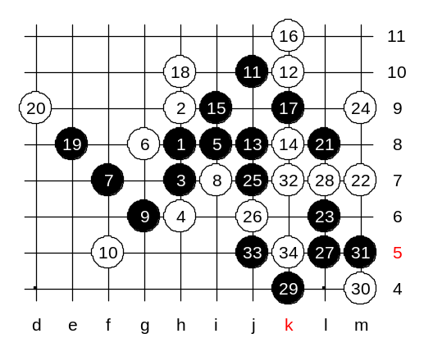
Another 12th move – k10. It is much stronger. Even I have played it in serious tournaments as white. :) Where is the next black move? True. The next black move is j8. After that there are only two strong white moves possible – k8 and j11. Other white moves lose fast. Lets go k8 first. In the last World Champion A final, a China player Zhang played this move against Sinyov as white. Sinyov could not recall the black win and lost that game. Lets find out how black should have won in their game. Zhang used 18-h10. The 25th move – a critical moment. This is the moment when Sinyov made a mistake. Sinyov played j6 and failed the black attack. I ask you, what is the correct black move? Wow, nobody guessed right. It is j7. :)
Move 34-k5. This is the medium level homework. Please find black win.

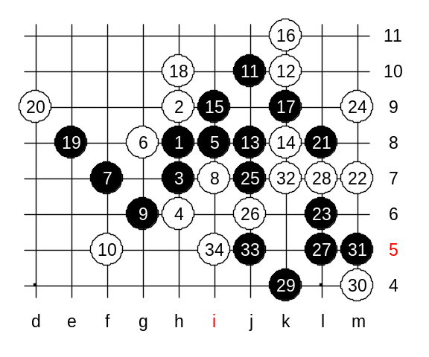
This is the advanced level homework. Please find black win.

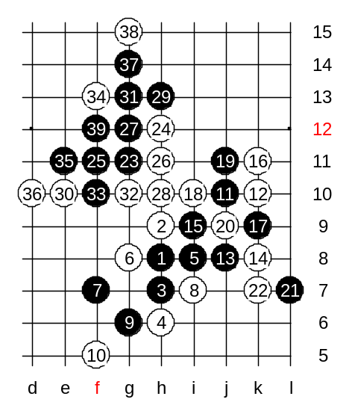
We still have some time. Lets play a training game. I will play some gambling position, and your duty is to use good teamwork and use you chance to get win. If you fail then your teamwork was not good enough. If you win then I will congratulate you for good work! :)

Finally you won! Good job again! I can see your team is still very strong and unbreakable.
Very good job!
Next time, I will give you harder puzzle! ;)

The lesson is over now, thank you all for coming! See you again next week!

